**Sub – pixel image registration in Python :**

→ Three new algorithms for 2D translation image registration to within a small fraction of a pixel that use nonlinear optimization and matrix-multiply discrete Fourier transforms are compared.

→ These algorithms can achieve registration with an accuracy equivalent to that of the conventional fast Fourier transform upsampling approach in a small fraction of the computation time and with greatly reduced memory requirements.

→ Their accuracy and computation time are compared for the purpose of evaluating a translation-invariant error metric.

**(1) Let’s read our images :**

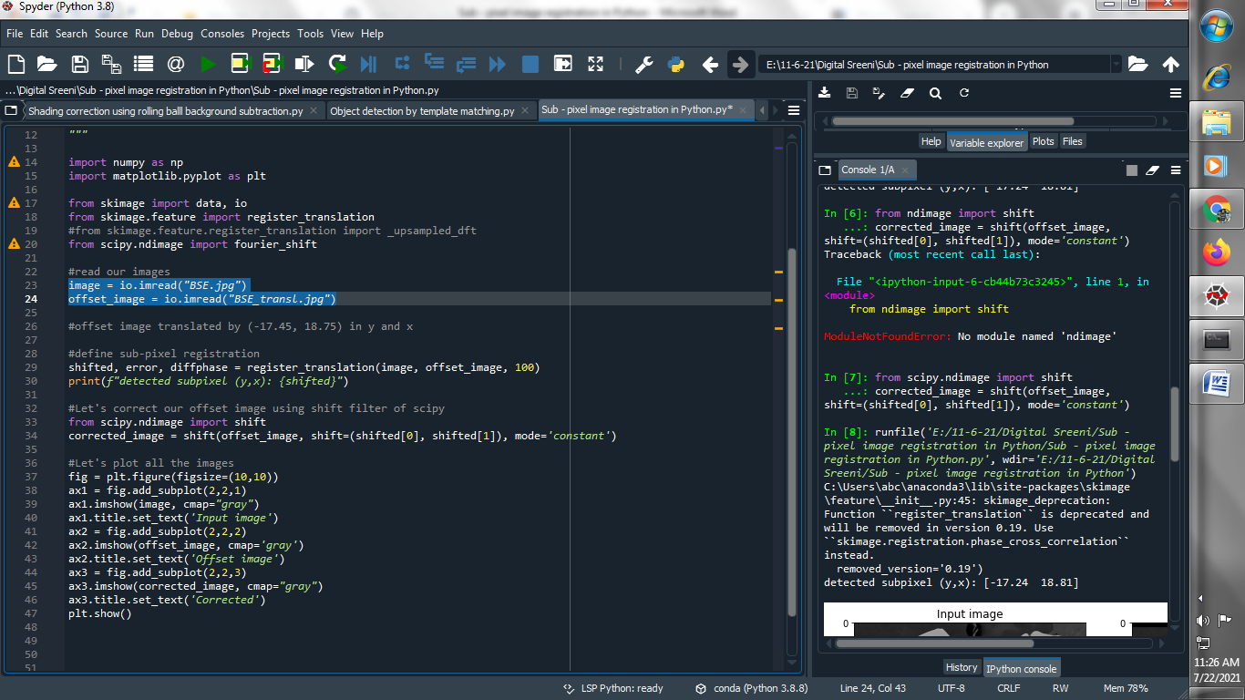

**(2) define sub-pixel registration :**

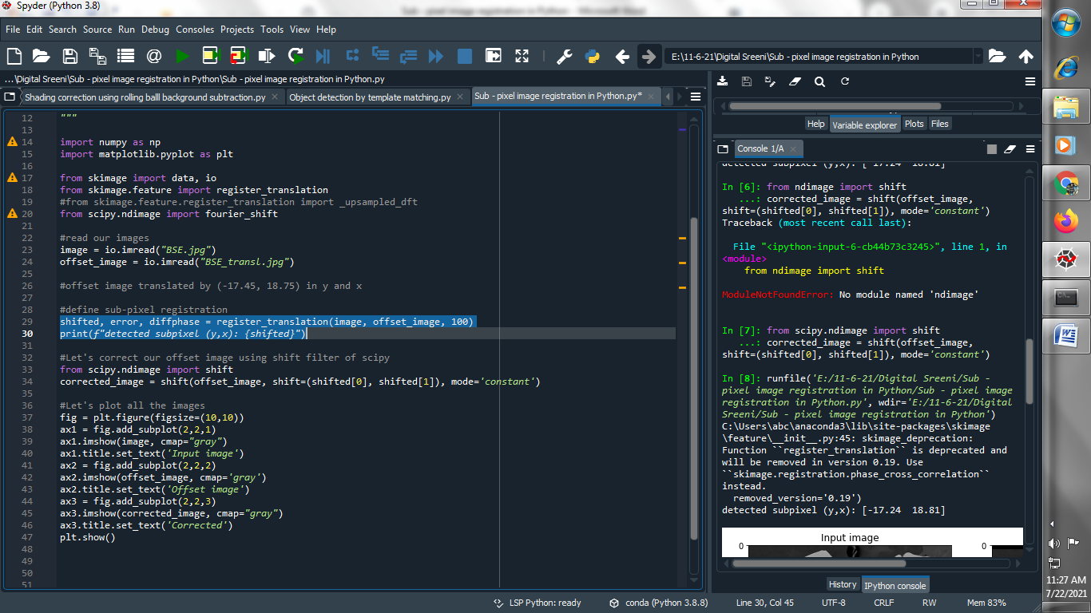

**Output :**

**detected subpixel (y,x): [-17.24 18.81]**

**(3) Let's correct our offset image using shift filter of scipy :**

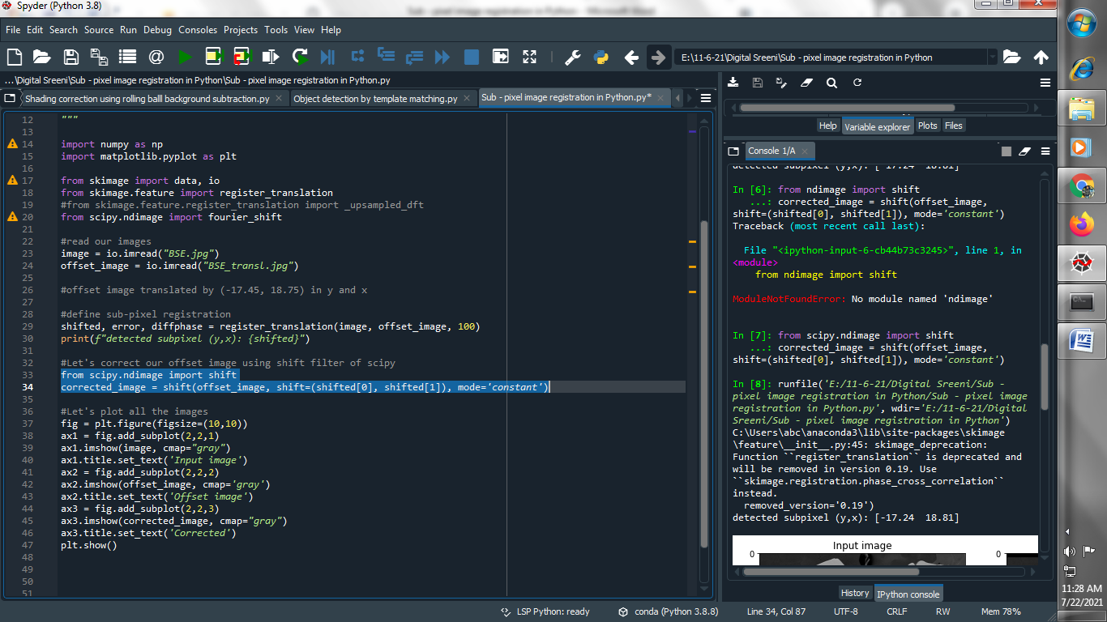

**(4) Let’s plot all the images :**

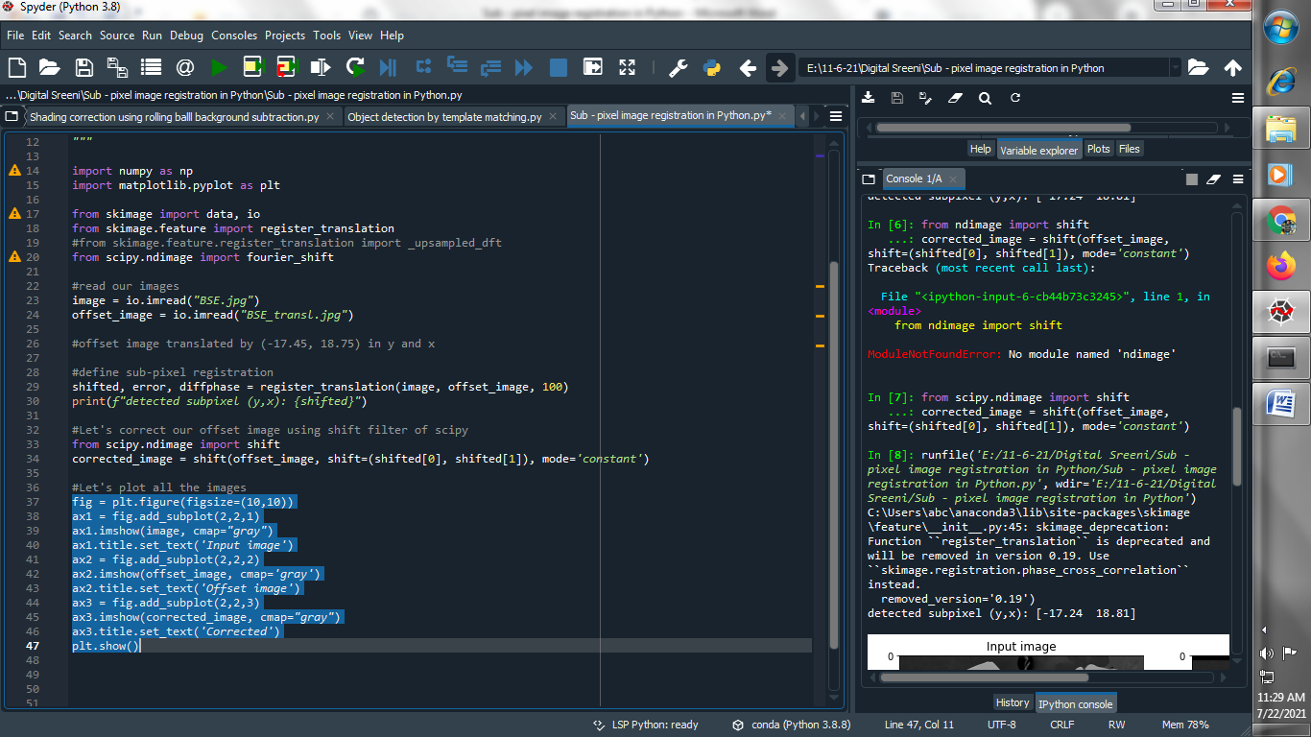

**Output :**

